**ZEESHAN AZIZ – SP20-BSE-071**

**RAILWAY RESERVATION SYSTEM**

**Book Ticket (USE CASE)**

**BRIEF**

This use case will begin when the passenger wants to book a ticket. Passenger will click the book ticket button and fill his details that include his current city and destination city. Then passenger will select his seat and confirm booking.

The ticket of the passenger will be booked.

**USE CASE DIAGRAM**

**FULLY DRESSED DIAGRAM**

|  |  |
| --- | --- |
| **USE CASES** | **COMMENT** |
| Use Case Name | Booking ticket |
| Scope | Railway Reservation System |
| Level | User Goal |
| Primary Actor | Passenger |
| Stockholders and Interests | Passenger: wants to book a ticket  Admin: wants to verify ticket details |
| Preconditions | The passenger has registered and logged in |
| Success Guarantee | The passenger has successfully booked a ticket. |
| Main Success Scenario | The user will provide details about his seat, destination and address and ticket will be booked |
| Extensions | If the details are entered wrong booking will fail and all steps will be repeated |
| Special Requirements | Maintainability, usability, and reliability |

**Domain Model**

**System Sequential Diagram**

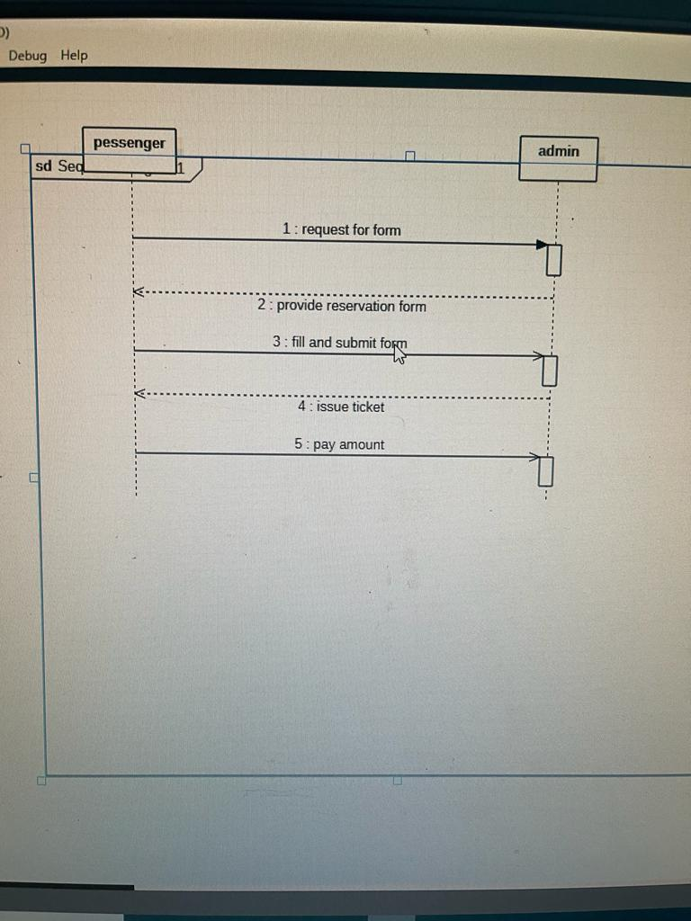

**Operation Contracts**

**RAILWAY RESERVATION SYSTEM**

**BOOKING TICKET (USE CASE)**

**book ticket**

**Operation location, adding, payment**

**Cross reference book ticket**

**Pre-condition the passenger has registered and logged in**

**Post condition 1 the passenger will tell the destination (location)**

**2 user id**

**3 seat availability**

**4 approving payment**

**5 end of purchasing**